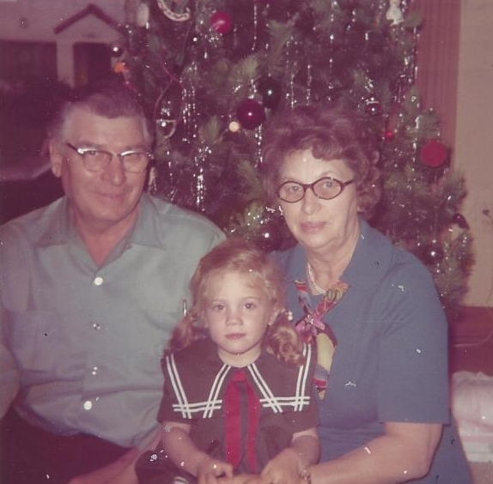

Russell & Mary Wolfe & Elaine Moore – 1972

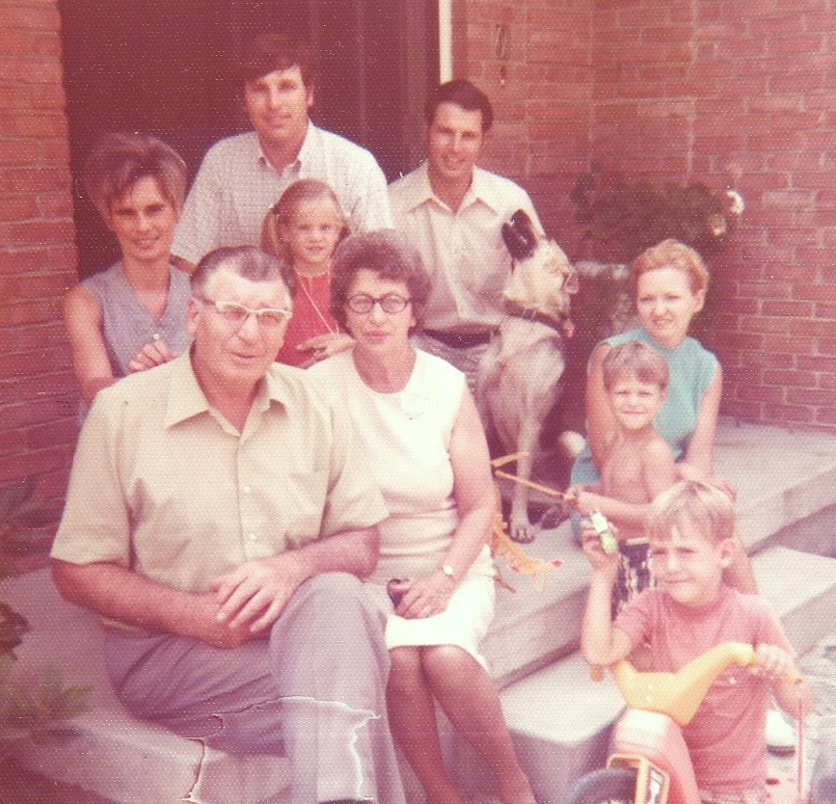

Donna, Nelson, Elaine, John, dog,

Russell, Mary, Linda, Tyler & Brian – 1972